EXPERIMENT 14
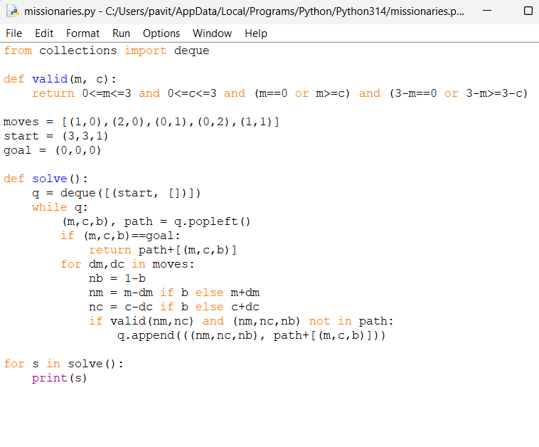
OUTPUT
